Lab Sheet 6: MongoDB Basic commands

1)
Code:
// 1. Create and select database
use('vehicles')

// 2. Display all databases
db.getMongo().getDBs()

// 3. Create collections
db.createCollection("two_wheelers", { capped: true, size: 50000 })
db.createCollection("four_wheelers")

// 4. Insert 5 documents into two_wheelers
db.two_wheelers.insertMany([
{
bike_name: "Hero Splendor",
model: "gear",
category: "100cc",
colors_available: ["black","red","blue"],
manufacturer: "Hero",
performance: 7,
timestamp: new Date("2018-01-10"),
price: 75000
},
{
bike_name: "Honda Activa",
model: "gearless",
category: "125cc",
colors_available: ["white","red","blue"],
manufacturer: "Honda",
performance: 8,
timestamp: new Date("2020-06-15"),
price: 85000
},
{
bike_name: "Bajaj Pulsar",
model: "gear",
category: "150cc",
colors_available: ["black","sport red","blue"],
manufacturer: "Bajaj",
performance: 9,
timestamp: new Date("2019-03-20"),
price: 110000
},
{
bike_name: "TVS Apache",
model: "gear",
category: "200cc",
colors_available: ["black","red"],
manufacturer: "TVS",
performance: 9,
timestamp: new Date("2021-09-12"),
price: 135000
},
{
bike_name: "Suzuki Access",
model: "gearless",
category: "125cc",
colors_available: ["white","black","silver"],
manufacturer: "Suzuki",
performance: 8,
timestamp: new Date("2017-11-05"),
price: 80000
}
])

// 5. Insert 5 documents into four_wheelers
db.four_wheelers.insertMany([
{
vehicle_name: "Maruti Swift",
model: "own",
category: "car",
variants: ["vxi","zxi","petrol"],
manufacturer: "Maruti",
performance: 8,
timestamp: new Date("2020-02-01"),
price: 700000
},
{
vehicle_name: "Tata Ace",
model: "commercial",
category: "mini truck",
variants: ["diesel"],
manufacturer: "Tata",
performance: 7,
timestamp: new Date("2018-07-10"),
price: 450000
},
{
vehicle_name: "Ashok Leyland Bus",
model: "commercial",
category: "bus",
variants: ["diesel"],
manufacturer: "Ashok Leyland",
performance: 8,
timestamp: new Date("2019-05-22"),
price: 2500000
},
{
vehicle_name: "Mahindra Bolero",
model: "own",
category: "car",
variants: ["diesel","zxi"],
manufacturer: "Mahindra",
performance: 7,
timestamp: new Date("2017-08-15"),
price: 950000
},
{
vehicle_name: "Eicher Truck",
model: "commercial",
category: "heavy truck",
variants: ["diesel"],
manufacturer: "Eicher",
performance: 6,
timestamp: new Date("2016-04-10"),
price: 1800000
}
])

// 6. Display all documents
db.two_wheelers.find()
db.four_wheelers.find()

// 7. Display vehicle name and price
db.two_wheelers.find({}, {bike_name:1, price:1, _id:0})
db.four_wheelers.find({}, {vehicle_name:1, price:1, _id:0})

// 8. Display two wheelers from a particular company (example: Honda)
db.two_wheelers.find({manufacturer: "Honda"})

// 9. Display four wheelers available in diesel variants
db.four_wheelers.find({variants: "diesel"})

// 10. Display vehicle name, category and manufacturer where rating > 5
db.two_wheelers.find({performance: {$gt: 5}}, {bike_name:1, category:1, manufacturer:1, _id:0})
db.four_wheelers.find({performance: {$gt: 5}}, {vehicle_name:1, category:1, manufacturer:1, _id:0})

Output:
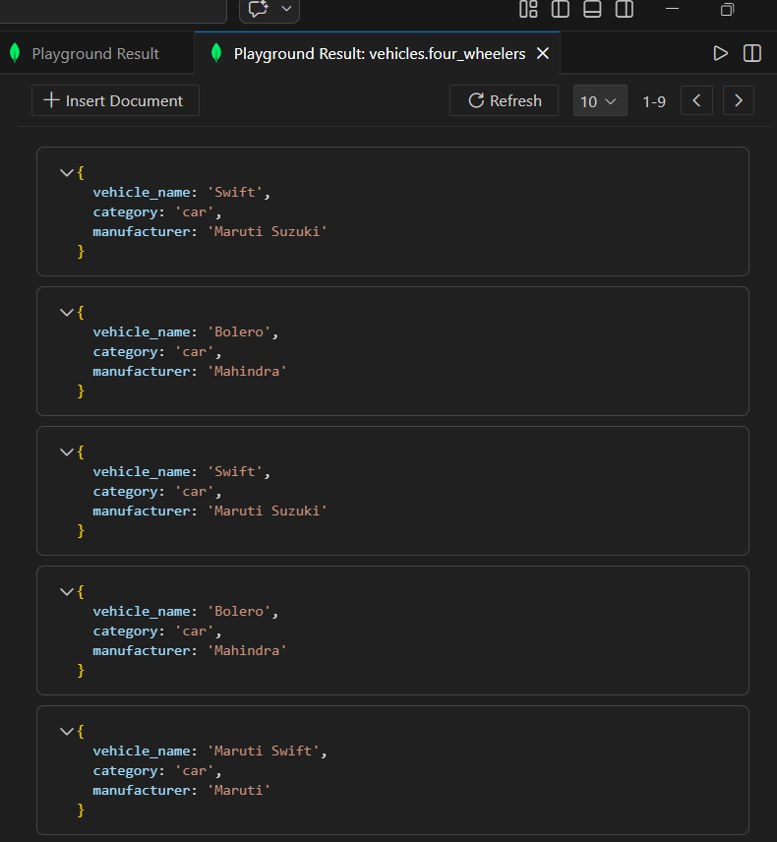
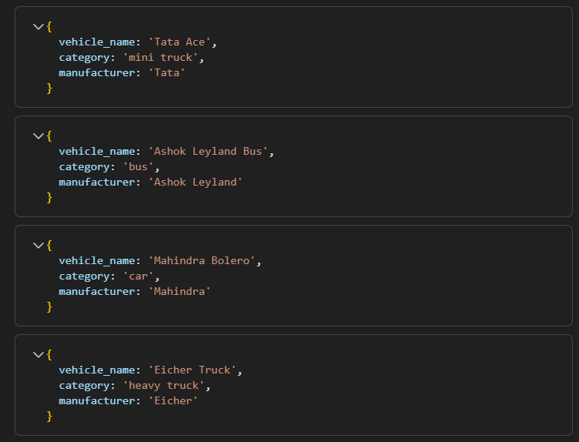

2)
Code:
// 1. Create and select database
use('animal')

// 2. Display all databases
db.getMongo().getDBs()

// 3. Create collections
db.createCollection("wild_animals", { capped: true, size: 50000 })
db.createCollection("domestic_animals")

// 4. Insert 5 documents into wild_animals
db.wild_animals.insertMany([
{
animal_name: "Lion",
nature: "harm",
favorite_foods: ["meat","deer"],
care_taker_name: "Ramesh",
life_span: 14,
timestamp: new Date("2018-02-10"),
expenses: 50000
},
{
animal_name: "Tiger",
nature: "harm",
favorite_foods: ["meat","rabbits"],
care_taker_name: "Suresh",
life_span: 15,
timestamp: new Date("2019-05-12"),
expenses: 55000
},
{
animal_name: "Elephant",
nature: "harmless",
favorite_foods: ["grass","fruits"],
care_taker_name: "Mahesh",
life_span: 60,
timestamp: new Date("2017-07-18"),
expenses: 70000
},
{
animal_name: "Leopard",
nature: "harm",
favorite_foods: ["meat","deer"],
care_taker_name: "Ramesh",
life_span: 12,
timestamp: new Date("2020-03-25"),
expenses: 45000
},
{
animal_name: "Bear",
nature: "harm",
favorite_foods: ["fish","fruits"],
care_taker_name: "Kiran",
life_span: 20,
timestamp: new Date("2016-11-05"),
expenses: 40000
}
])

// 5. Insert 5 documents into domestic_animals
db.domestic_animals.insertMany([
{
animal_name: "Dog",
gender: "male",
favorite_foods: ["meat","rice"],
animal_petname: "Tommy",
life_span: 12,
timestamp: new Date("2021-04-10"),
expenses: 8000
},
{
animal_name: "Cat",
gender: "female",
favorite_foods: ["fish","milk"],
animal_petname: "Kitty",
life_span: 10,
timestamp: new Date("2020-08-14"),
expenses: 6000
},
{
animal_name: "Cow",
gender: "female",
favorite_foods: ["grass","grain"],
animal_petname: "Lakshmi",
life_span: 20,
timestamp: new Date("2019-01-20"),
expenses: 15000
},
{
animal_name: "Goat",
gender: "male",
favorite_foods: ["grass","leaves"],
animal_petname: "Chotu",
life_span: 15,
timestamp: new Date("2018-06-12"),
expenses: 9000
},
{
animal_name: "Rabbit",
gender: "female",
favorite_foods: ["carrot","grass"],
animal_petname: "Bunny",
life_span: 8,
timestamp: new Date("2022-02-15"),
expenses: 5000
}
])

// 6. Display all documents
db.wild_animals.find()
db.domestic_animals.find()

// 7. Display only animal name and expenses
db.wild_animals.find({}, {animal_name:1, expenses:1, _id:0})
db.domestic_animals.find({}, {animal_name:1, expenses:1, _id:0})

// 8. Display domestic animals with a particular lifespan (example: 10 years)
db.domestic_animals.find({life_span: 10})

// 9. Display wild animals under a particular caretaker (example: Ramesh)
db.wild_animals.find({care_taker_name: "Ramesh"})

// 10. Display animal name, favorite_foods and expenses where lifespan > 5 years
db.wild_animals.find(
{life_span: {$gt: 5}},
{animal_name:1, favorite_foods:1, expenses:1, _id:0}
)

db.domestic_animals.find(
{life_span: {$gt: 5}},
{animal_name:1, favorite_foods:1, expenses:1, _id:0}
)

Output:
